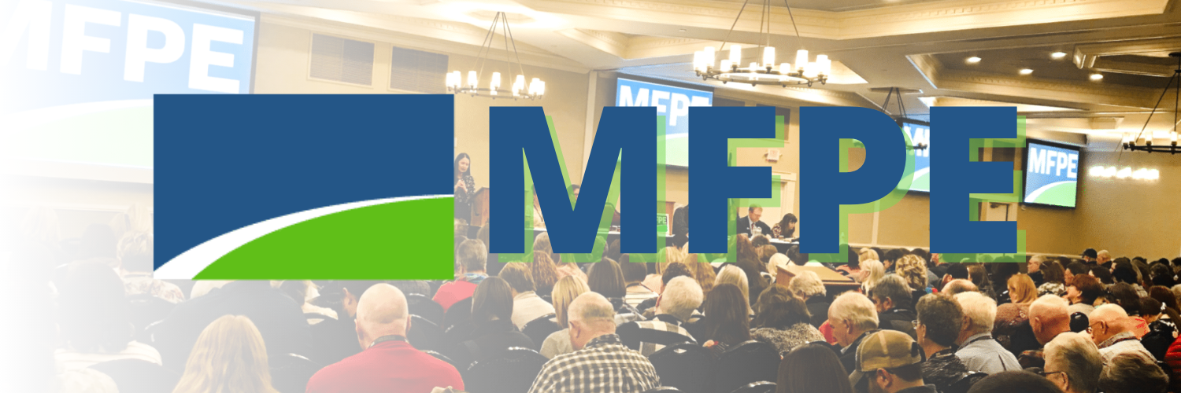

MFPE Annual Conference
April 8-9, 2022
Helena—Delta Hotels Helena Colonial

Index
- Tentative Schedule of Events
- Tentative Order of Business
- Calendar
- Governance District Map
- Board of Directors
- Hall of Fame
- Standing Rule Amendments
- Nominations and Elections
- NEA Representative Assembly
- MFPE Constitution
- Constitutional Amendments
- New Business Items Form
- Legislative Program
- Dues
- Budget
- MFPE PAC Form

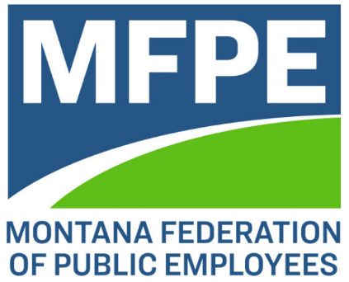
2022 MFPE Annual Conference

Tentative Schedule of Events
*All events at the Delta Hotels Helena Colonial unless otherwise noted.

Friday, April 8
10:00 am – 1:30 pm Delegate Registration
10:00 am Board of Directors convenes
12:15 pm Lunch
1:30 pm Conference convenes
6:00 pm Hall of Fame dinner at Helena Great Northern Hotel

Lunch will be provided on Friday and breakfast and lunch on Saturday. In addition, dinner will be provided as part of the Hall of Fame celebration Friday evening. No individually purchased meals will be reimbursed during the annual conference.

Saturday, April 9
7:00 – 8:00 am Breakfast
7:00 – 9:00 am Delegate Registration—delegates must be registered no later
than 9:00 am
8:00 – 9:30 am District Caucuses
District 1
District 2
District 3
District 4
District 5
District 6
Districts 7, 8
District 9
District 10 (MFPE-R)
MFPE Student Members

9:45 am Conference reconvenes
12:00 pm Lunch
4:00 pm Estimated Time of Adjournment

2022 MFPE Annual Conference
Tentative Order of Business

Friday, April 8
- Call to Order Amanda Curtis
- Invocation and Pledge of Allegiance Jordann Lankford-Forster
Bright Trail Woman
- Welcome and Introductions Amanda Curtis, Erik Burke
- Senator Jon Tester (invited)
- Delegate Orientation Amanda Curtis
- Standing Rules and Amendments Amanda Curtis
- Program Staff Report – MFPE-R and Member Benefits Sarah Piper
- Congressional Candidate Forum Amanda Curtis

Saturday, April 9
- District Caucuses (8:00 – 9:30 am) District Chairs
  - Election of Board Chair and Vice Chair – Districts 1 (vice chair only), 2, 4, 6, 8, 10
  - Election of 1 District Delegate and 1 Alternate to NEA RA
- Conference Reconvenes (9:45 am)
- Nominations and Elections Moffie Funk
  - President
  - 1st Vice President
  - 2nd Vice President
  - Treasurer
  - NEA Director
- Constitutional Amendments Amanda Curtis
- James Holbrook, MT AFL-CIO Executive Secretary
- Program Staff Report – Political Action Sam Telling
- Legislative Program Eric Matthews
- Vicky Byrd, MNA CEO
- Program Staff Report – Communications Bob Funk
- New Business Items Amanda Curtis
(Deadline for NBI’s is 9:00 am Saturday, April 9)
- Dues/Budget Michelle Wheat
- Adjournment Amanda Curtis

*During the conference, we will suspend business for several informational and celebratory events.

