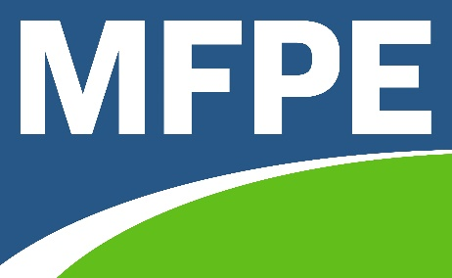
2022-23 MFPE Legislative Program
Submitted by MFPE BOD for approval of delegates to 2022 Annual conference

Public Programs & Services
MFPE supports legislation to:

- Fund a collectively bargained state and university employee pay plan that pays at minimum 100% of market rate, includes career ladders and location pay, and minimizes employee out-of-pocket health insurance costs.
- Provide public employees with additional paid family and bereavement leave.
- Fund full staffing of state and local government services.
- Adopt more robust longevity increments.
- Adopt cost of living adjustment increments.

MFPE opposes legislation to:

- Privatize public programs and services.
- Limit or deny opportunities for public employees to serve in public office.
- Cap state employee salaries and/or benefits.
- Further diminish staffing of state and local government services.
- Reclassify state employee positions.

Public Education
MFPE supports legislation to:

- Provide state funded public education opportunities to all pre-k school age children.
- Fund an annualized inflationary increase in state funding of special education.
- Qualify eligible classified school employees for unemployment insurance during school year breaks.
- Increase annual stipends for school district employees who earn National Board Certification or other nationally recognized advanced certification.
- Include state-funded stipends as pensionable.
- Provide state funding to help build, maintain, and improve public schools and facilities.
- Provide state funding to pay competitive salaries.
- Mandate compulsory enrollment from age 6 to age 18 or completion of high school diploma or equivalent.
- Provide 2-years of tuition-free education options at Montana’s publicly funded institutions.
- Increase funding for public higher education.
- Extend ANB funding for all students up to 20 years of age.
- Make the Montana University System 6-mill levy permanent.
- Adequately fund mental health services in public schools.
MFPE opposes legislation to:

- Invest public revenues in private schools, including charter and home schools.
- Dictate school accreditation and teacher licensure standards, curricula, and methods of instruction.
- Authorize school districts to employ non-licensed persons as professional educators.
- Diminish or repeal Montana teacher tenure.
- Circumvent the Federal Gun Free Schools Act.
- Infringe on the constitutional authority of education boards.

Union Rights
MFPE supports legislation to:

- Protect employees' security, safe working conditions, and health.

MFPE opposes legislation to:

- Impede the right of all public and private sector employees to organize and bargain collectively.
- Repeal fair share negotiated provisions and/or exclusive representation.
- Prohibit payroll deduction of union dues.

Taxation
MFPE supports legislation to:

- Create and maintain a state tax system that is adequate, equitable, balanced, simple, progressive, and universal.

MFPE opposes legislation to:

- Eliminate, cap, or significantly reduce property or income taxes without replacement revenue.

Retirement
MFPE supports legislation to:

- Increase state funding of the Montana University System Retirement Plan.
- Guarantee the continued stability of Montana’s public pensions systems.

MFPE opposes legislation to:

- Eliminate or diminish public employee defined benefit retirement plans.
- Reduce or eliminate guaranteed annual benefit adjustments in public employee pensions.
Health Care
MFPE supports legislation to:

- Expand Medicaid to all eligible Montana citizens without work requirements.
- Create a mandatory statewide public prek-12 school employee health care insurance risk pool and minimize employee out-of-pocket.
- Permit school districts to enroll in the state employee health insurance risk pool.
- Expand access to state health clinics.
- Expand access to mental healthcare.
- Guarantee access to affordable, quality healthcare.

MFPE opposes legislation to:

- Create or implement public health policies that lack support of healthcare professionals.

Constitutional and Voting Rights
MFPE supports legislation to:

- Require rigorous petition gathering processes of efforts to qualify 3rd parties for general election ballot status.
- Modernize Montana elections, including promoting mail balloting, expanding polling locations, and adopting online and/or automatic voter registration.
- Provide access to candidate information.

MFPE opposes legislation to:

- Deny or impede any eligible citizen’s right to register and vote.
- Deny or impede any citizen’s right and ability to participate in our Democracy.
- Infringe on the constitutional separation of powers outlined in Article III.

Public Lands
MFPE opposes legislation to:

- Transfer federal public property to state or private ownership.
- Restrict or eliminate public access to state and federal land and water.

