MFPE EZ-DUES ENROLLMENT INSTRUCTIONS
Member Power, Made Easy in 7 Steps

STEP 1: Navigate to the EZ-Dues website at: mfpe.org/edues
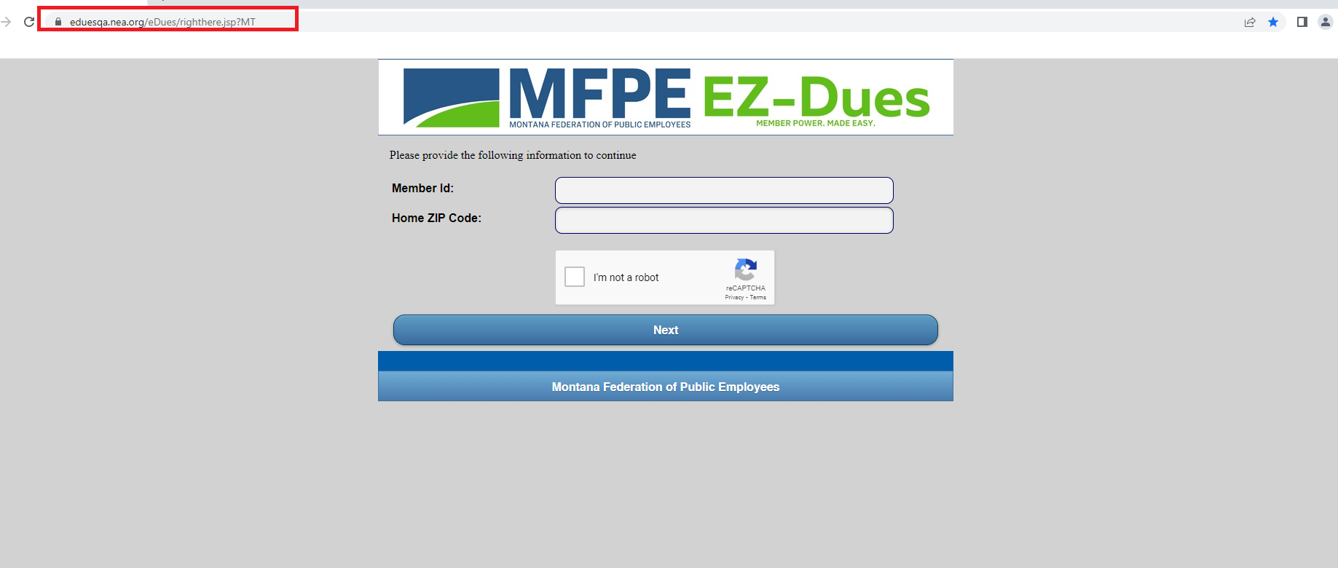
STEP 2: Enter your Membership ID number and your home address zip code. 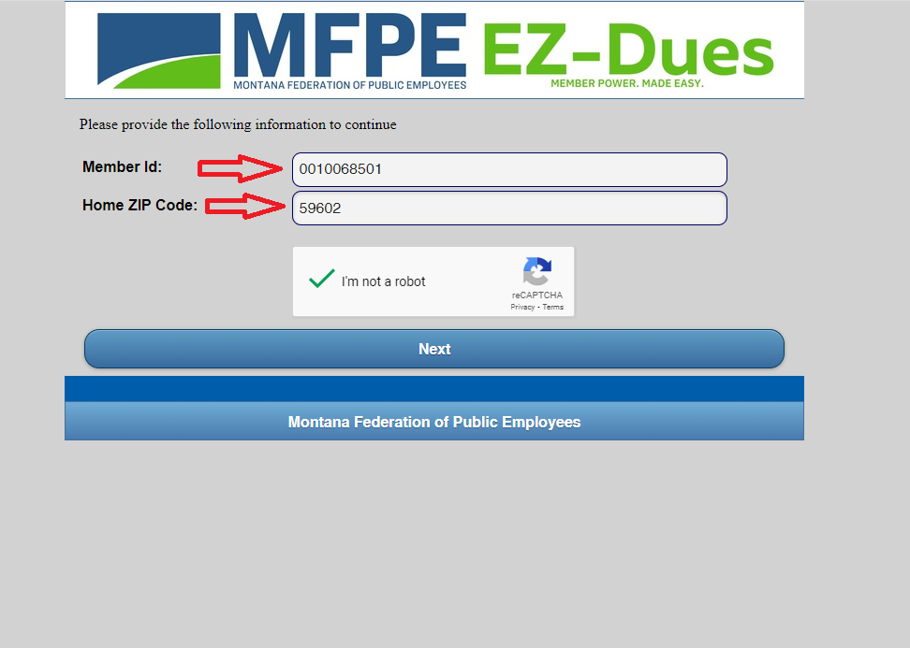*complete security reCAPTCHA if prompted

STEP 3: Verify if contact and local information is correct and add personal email. Click Next. 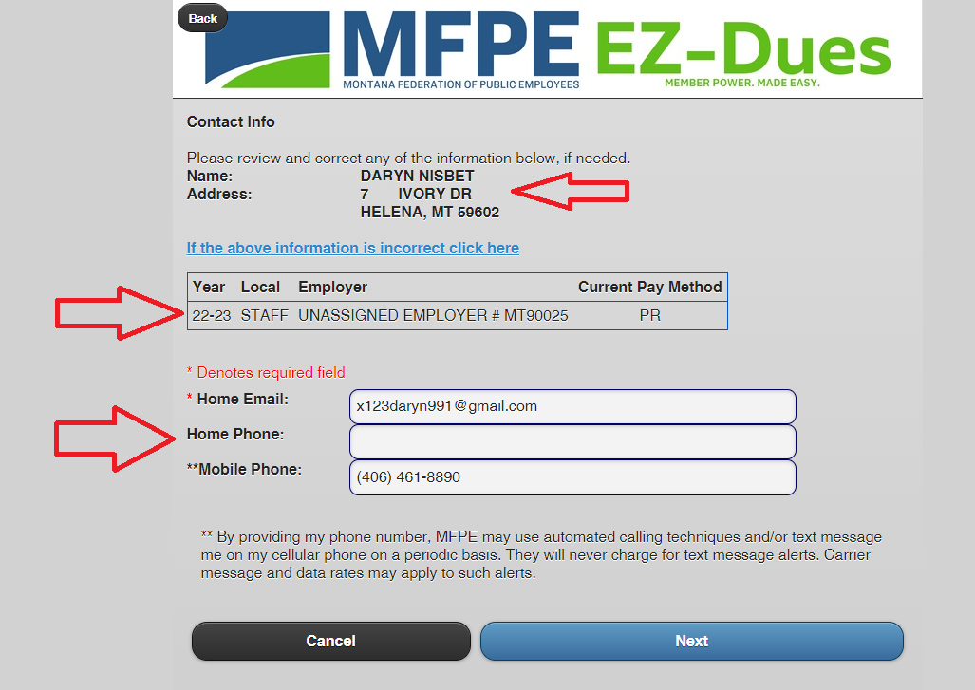

STEP 4: Select payment method and verify obligation amounts by fund. Click Next.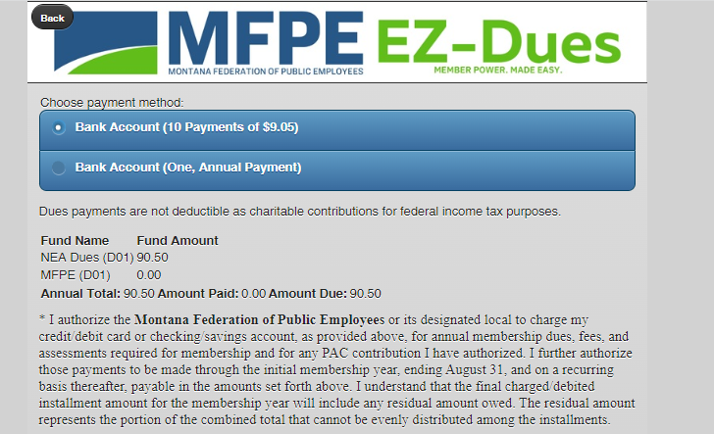

STEP 5: [OPTIONAL] Add any additional funds. If none, leave blank and click Next.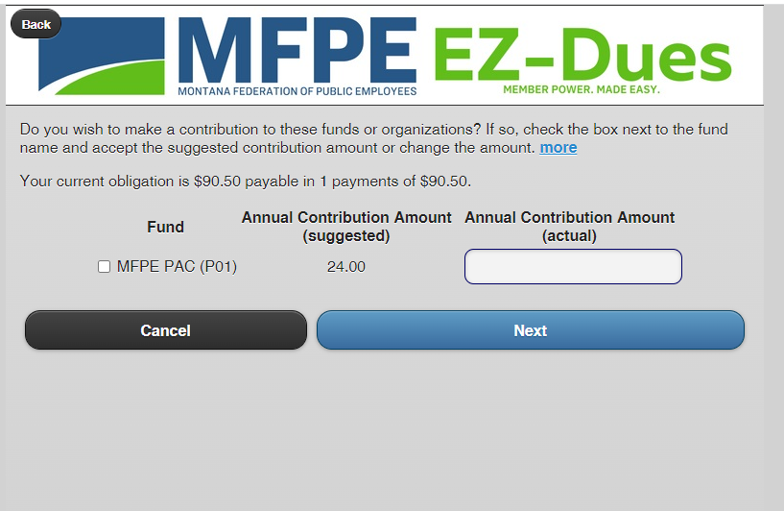

Step 6: Fill in Bank Routing Number, choose account type and enter account number.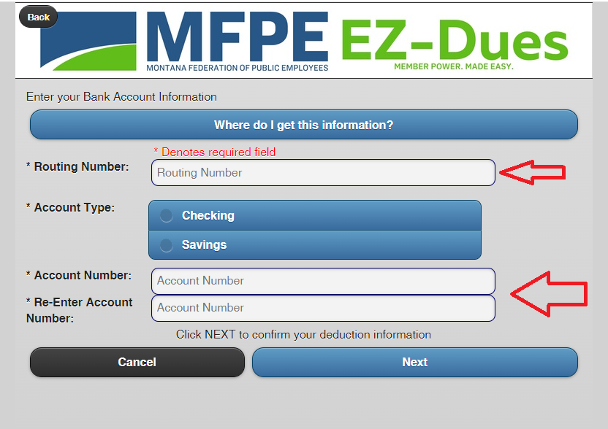

STEP 7: Verify information looks accurate and check “I agree”. Click CONFRIM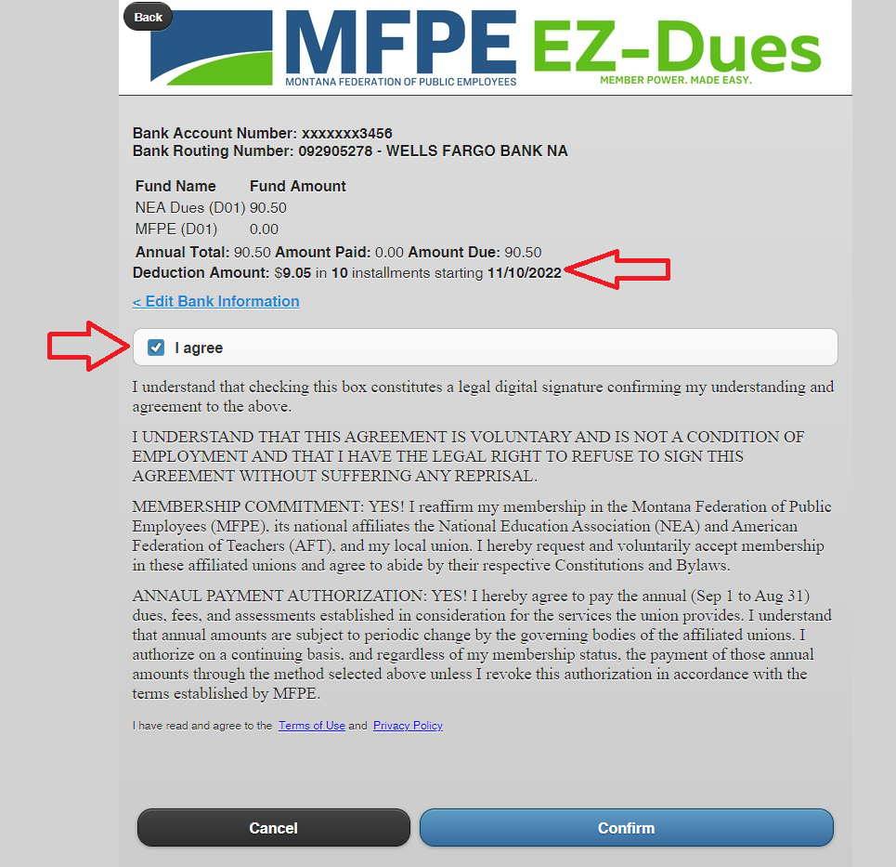

You will be presented with a final confirmation screen and have successfully enrolled in EZ-Dues! You will receive a verification email.

