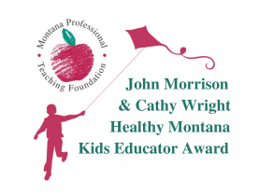
APPLICATION

Name

Home Address

Home/Cell Phone Email Address

Subject Taught/Position Grade level

Name of School ________________________________________

Professional Biography (maximum 200 words – please attach)
Please describe your background and career in education, including what influenced you to become an educator or school employee. Describe what you consider to be your most significant contributions and accomplishments in education.

Fostering Healthy Lifestyles and Choices (maximum 500 words – please attach)
Please describe what you have done to engage Montana public school students in fostering a commitment to healthy lifestyles and choices as described in the John Morrison Healthy Montana Kids Educator Award information summary (attached). Please provide specific examples and evidence of how students have benefited from your efforts. You are welcome to include attachments such as newspaper articles, student work samples, web links. However, attached information should not exceed 5 total pages.

If selected, the awardee will be required to attend the MPTF 2024 Awards for Teaching Excellence Celebration that will take place on October 17, 2024, in conjunction with the MFPE Educator Conference in Bozeman. In addition, awardees will be expected to present a 50-minute workshop during the 2025 MFPE Educator Conference in Missoula, in October of 2025, to share information about your work and professional development experiences.

Should I be selected as the 2024 John Morrison Healthy Montana Kids Educator Award winner, I hereby agree to the commitments stated above and give my permission that any or all of the attached materials may be shared with persons interested in promoting the Award program.

Signature of nominee

Completed applications including 1) this application page; 2) the two essays listed above; and 3) relevant attachments must be RECEIVED no later than August 15, 2024.
Mail completed application to John Morrison Healthy MT Kids Educator Award, 1232 E. 6th Ave, Helena MT 59601.

